Mini 4K HDMI To Fiber Converter
HT401-4KHDMI-T/R-MINI
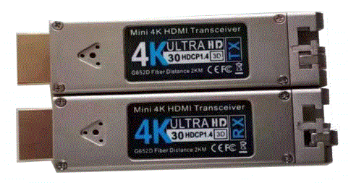

Thumb size, easy for carrying and tight space installation like server cabinet
Support Max HDMI 3840*2160@30Hz
Support HDMI 1.4M
Support DDC CEC HPD signal
No need configuration, auto-negotiation, auto recognize EDID and CEC
Transmission distance over singlemode max 20km(standard 2km for supporting EDID)
Standard HDMI connector
Built-in Micro-b USB connector for power input
Support plug and play
Good EMI and RMI resistance
Fiber wavelength 1310nm, LC interface, support dual fiber or single fiber
Operation temperature: -20~70 degree.

Technical specifications
Item | Specifications
Rate per channel | 10Gbps
Power consumption | 1420mW Tx side  1220mW Rx side
Power input | 5V/+-5%
Max resolutions | Up to 3840*2160P
Refresh Frequency | 30Hz
Color depth | Up to 48bit
Wavelength | 1310nm
BER | ‹1.00E-12
Laser output power | Class i EN 60825-1 2007  EN 60825-2 A2 2010
Electric interface | 19pin HDMI Type A port  4 pin USB standard A

