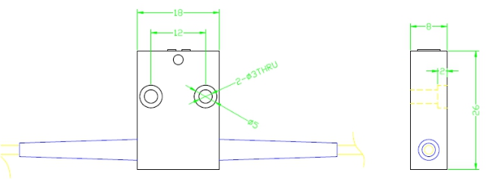

Fiber optic innovator

Single Mode Manual Variable Optical Attenuator (MVOA)

Features
High precision
Wide attenuation range Low Insertion Loss Compact size
Application
Optical communication systems test Optics lab use

Specifications:

Type  Parameter | 1310nm | 1550nm | 1310/1550nm | 1064
Wavelength (nm) | 1310 ± 40 | 1550 ± 40 | 1310 ± 40 & 1550  ± 40 | 1064 ± 20
Attenuation range (dB) | 0.6 ~ 60 | 0.6 ~ 60 | 0.8 ~ 60 | 0.6 ~ 60
Insertion Loss (dB) | ≤0.6 | ≤0.6 | ≤0.8 | ≤0.6
Return loss (dB) | ≥50 |  |  | ≥50
Fiber Type | SMF-28e |  |  | HI1060
Adjustment Precision (dB) | 0.02
PDL (dB) | ≤0.15
Operating temperature (℃) | 0 ~ +70
Storage temperature (℃) | -40 ~ +85
Dimension (mm) | 26 x 16 x 8

Package Dimensions

Ordering Information

HT-MVOA | Wavelength | Adjustment  Type | Pigtail Type | Fiber Type | Length | Connector
 | 1064 1310 1550  1310/1550 | 1= Hand  adjustment  2= Screw  adjustment | 900=900um loose  tube  2000=2mm loose  tube  3000=3mm loose  tube | 1=SMF-28e  4=HI1060 | 1= 1m | NE=None FA=FC/APC FC=FC/UPC SA=SC/APC SC=SC/UPC LC=LC/UPC LA=LC/APC MU=MU/UPC XX=Other

www.htopto.com

