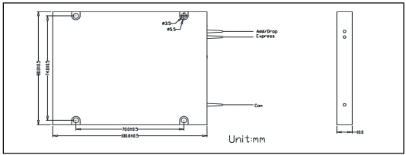
① | Channel Space | 1=100GHz; 2=200GHz;
② | Channel Type | 1CH;
③ | ITU Grid | 21=21ch; 21*=21*ch; 22=22ch; 22*=22*ch; …; 72*=72*ch;
④ | Pigtail Type | 250=250um Bare Fiber; 900=900μm loose tube; 3000=3mm Cable;
⑤ | Fiber Type | 1=SMF-28e;
⑥ | Fiber Length | 1=1m;
⑦ | Connector | NE=None; FA=FC/APC; FC=FC/UPC; SA=SC/APC; SC=SC/UPC; LC=LC/UPC; XX=Others;
⑧ | Package | 100x80x10; LGX;



Fiber optic innovator _

High Isolation Dense Wavelength Division Multiplexer (DWDM)

Features Applications

High Demux Channel Isolation Long Haul DWDM System

Low Polarization Dependent Loss Metro DWDM System

Flat and Wide Passband Access/Enterprise Network

High Reliability Test Instrument

C34 1550.12

Specifications C15 1565.50

Parameters |  | Unit | 100G | 200G
Channel Wavelength CWL |  | nm | ITU Grid
Center Wavelength Accuracy |  | nm | ±0.05
Channel Passband (@-0.5dB Bandwidth) |  | nm | ≥0.22 | ≥0.50
Insertion Loss | Add / Drop CH | dB | ≤1.0
Insertion Loss | Express CH | dB | ≤1.0
Isolation | Add / Drop CH | dB | ≥40
Isolation | Express CH | dB | ≥30 for adj Channel, ≥40 for non-adj Channel
Insertion Loss Temperature Sensitivity |  | dB/°C | ≤0.003
Wavelength Temperature Shifting |  | nm/°C | ≤0.002
PDL |  | dB | ≤0.30
PMD |  | ps | ≤0.10
Directivity |  | dB | ≥50
Return Loss |  | dB | ≥45
Fiber Type |  |  | SMF-28e
Fiber Length |  | m | 1.0
Power Handling |  | mW | ≤300
Operating Temperature |  | ℃ | -0 ~ +70
Storage Temperature |  | ℃ | -40 ~ +85
Dimensions |  | mm | 100x80x10

* Insertion Loss +0.2dB, and Return Loss -5dB if add connector.
* RoHS Compliant. Package Dimensions

Ordering Information
HT-DWDM- ①-②②②-③③-④④④-⑤-⑥-⑦⑦-⑧⑧⑧⑧⑧⑧⑧⑧⑧

_____________________________

http://www.htopto.com

