Fiber Optic Innvator

Compact CWDM Module (Mini CWDM)

Features
Low insertion loss & High channel isolation High stability and reliability
Application
CWDM system Metro/Access Networks CATV Fiberoptic System

Specifications

Parameter |  | 4 Channels | 8 Channels
CWDM Channel Insertion Loss (dB) |  | ≤1.0 (Typ 0.8) | ≤1.5 (Typ 1.0)
Upgrade channel Insertion Loss (dB)  (Optional) |  | ≤1.0 | ≤1.5
Central wavelength (nm) |  | 1471, 1491, 1511, 1531, 1551, 1571, 1591, 1611
Channel space (nm) |  | 20
Channel bandwidth (nm) |  | λc ± 6.5
Isolation  (dB) | adjacent channel | ≥30
Isolation  (dB) | non-adjacent channel | ≥45
Directivity (dB) |  | ≥55
Return loss (dB) |  | ≥45
PDL (dB) |  | ≤0.20
PMD (ps) |  | ≤0.20
Power handling (mW) |  | ≤300
Operating temperature (℃) |  | 0 ~ +70
Storage temperature (℃) |  | -40 ~ +85
Dimensions (mm) |  | 50x28.8x6.5

Package Dimensions:
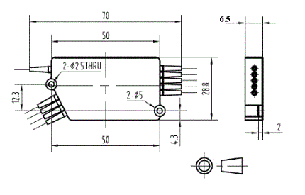

Ordering Information:

MCWDM | Type | Port  Type | Wavelength | Pigtail Type | Fiber Type | Length | UpgradeType | Connector
 | M=Mux  D=Demux | 4=4ch  8=8ch | 1471  1491  ……  1611 | 250=250um  900=900um | 1=SMF-28e | 1= 1m | WO=W/O UPG Ch W=With UPG Ch | NE=None FA=FC/APC FC=FC/UPC SA=SC/APC SC=SC/UPC LC=LC/UPC LA=LC/APC XX=Other

www.htopto.com

