

Fiber optic Innovator

1x2 PON Filter WDM

Features
Wide pass band
Low insertion loss and High channel isolation
High stability and reliability
Application
FTTH/PON

Specifications

Parameter | 1×2 FWDM
Central wavelength (nm) | 1310, 1490, 1550 | 1310,1550,1625
Operating Wavelength (nm) | 1310±40, 1490±10 , 1550±10 | 1310±20, 1550±20 ,  1625±20
Pass/Reflection wavelength (nm) | T1310/R1490,1550 T1550/R1310,1490 T1490/R1310,1550 T1310,1490/R1550 T1490,1550/R1310 | T1310,1550/R1625  T1625R1310,1550
Pass insertion loss (nm) | ≤0.8
Reflection insertion loss (dB) | ≤0.6
Pass Isolation(dB) | ≥30
Reflection Isolation(dB) | ≥15
Directivity(dB) | ≥55
Return loss(dB) | ≥50
PDL( dB) | ≤0.1
Wavelength thermal stability (nm/ ℃) | ≤0.003
Insertion loss thermal stability (dB/ ℃) | ≤0.005
Power handling (mW) | ≤500
Operating temperature(℃) | 0 ~ +70
Storage temperature(℃) | -40 ~ +85
Dimensions (mm) | Ф5.5× L34

Package Dimensions
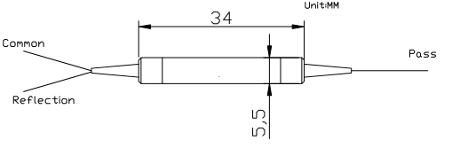

Ordering Information

FWDM | Port Type | Wavelength | Pigtail Type | Fiber Type | Length | Connector
 | 1x2 | T1550/R1310,1490 T1490/R1310,1550 T1310,1490/R1550 T1490,1550/R1310 T1310,1550/R1625 T1625R1310,1550 | 250=250um bare  fiber  900=900um loose  tube  3000=3mm loose  tube | 1=SMF-28e | 1= 1m X=Specify | NE=None FA=FC/APC FC=FC/UPC SA=SC/APC SC=SC/UPC LC=LC/UPC LA=LC/APC XX=Other

www.htopto.com

