

Fiber optic innovator

Filter WDM (980/1064, 980/1550, 1064/1030, 1550/1064 1480/1550nm)

Features
Low Insertion Loss & High Isolation
High Stability and reliability
Application
Fiber Amplifier Fiber Laser Fiber Instrument

Specifications

Type  Parameter | 1480/1550 | 980/1064 | 980/1550 | 1064/1030 | 1550/1064
Pass wavelength (nm) | 1530-1580  (or 1440-1490) | 960-990 (or  1020-1080) | 1520-1600 | 1064+/-2.5 | 1500~1600
Reflection wavelength (nm) | 1440-1490 (or  1530-1580) | 1020-1080  (or 960-990) | 965-1000 | 1030+/-10 | 1040~1064
Pass insertion loss (dB) | ≤0.6 | ≤0.8 | ≤0.8 | ≤0.8 | ≤0.8
Reflection insertion loss (dB) | ≤0.5 | ≤0.6 | ≤0.6 | ≤0.6 | ≤0.6
Pass channel isolation (dB) | ≥30 | ≥25 | ≥30 | ≥25 | ≥25
Reflection isolation (dB) | ≥13 | ≥13 | ≥18 | ≥13 | ≥13
Channel flatness (dB) | ≤0.3 | ≤0.3 | ≤0.3 | ≤0.3 | ≤0.3
Directivity (dB) | ≥55
Return loss (dB) | ≥50
PDL (dB) | ≤0.1
Wavelength thermal stability (nm/℃) | ≤0.003
Insertion loss thermal stability( | ≤0.005
Power handling (mW) | ≤300
Operating temperature (℃) | 0 ~ +70
Storage temperature (℃) | -40 ~ +85
Dimensions (mm) | φ5.5×L34

Package Dimensions

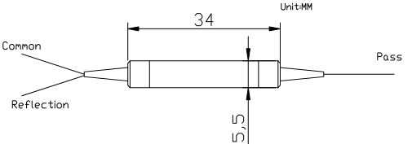

Ordering Information

FWDM | Wavelength | Pigtail Type | Fiber Type | Length | Connector
 | 1064T/1030R 980T/1064R 980R/1064T 1550T/980R 1480T/1550R 1550T/1480R 1550T/1064R | 250=250um bare fiber  900=900um loose tube  3000=3mm loose tube | 1=SMF-28e  4=HI1060 | 1= 1m | NE=None FA=FC/APC FC=FC/UPC SA=SC/APC SC=SC/UPC LC=LC/UPC XX=Other

www.htopto.com

