Several common types of fiber optic connectors (ST,SC,LC,FC) and the differences between PC, APC and UPC.

- A few common fiber optic connectors (ST, SC, LC, FC)
FC type fiber optic connector: the external reinforcement is a metal sleeve and the fastening method is screw fastening. Usually used on the ODF side (most often used on patch panels).
SC type fiber optic connector: connector to connect GBIC optical module or ordinary fiber optic transceiver, it has a rectangular housing, fastening method is plug and latch type, do not need to rotate. (Used most often on router switches.)
ST type fiber optic connector: commonly used in fiber optic patch panels, with a rounded housing and a screw fastening method. (For 10Base-F connections, the connector is usually of the ST type. Commonly used for fiber optic patch panels)
LC-type fiber optic connector: a connector that connects to SFP modules and is made with an easy-to-operate modular jack (RJ) latch mechanism. (Commonly used in routers)
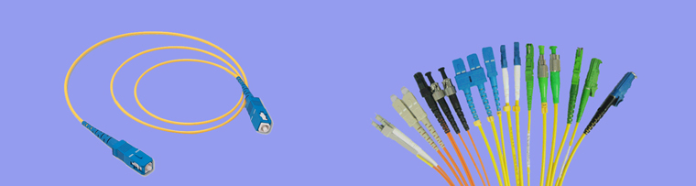
- Second, the difference between the optical adapter PC, APC and UPC
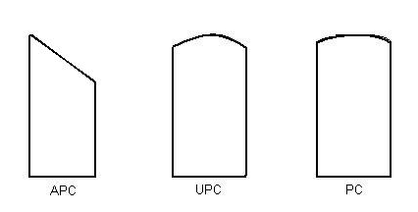
Common fiber optic connectors in the laboratory are mainly FC / PC and FC / APC two. Here the FC refers to the ferrule contactor, is a steel metal sleeve (fiber optic connectors and cable connectors, a difference is the metal texture, cable connectors are mostly copper, in order to conductive; and fiber optic connectors are not conductive that copper is both soft and expensive but also rusty).
For both metal connectors are only, often ignoring the two abbreviations. Such as FC / PC we can conventionally known as PC, while the APC refers to the FC / APC.
PC refers to close contact (physical contact), also close contact, according to the different return loss, the connector is divided into PC, SPC, UPC and APC, SPC and UPC industry standards provide for the return loss of -35dB, -40dB and -50dB respectively (return loss refers to the proportion of light is reflected by the end-face of the connector, the smaller the return loss the better, of course, you can also say that the value of the return loss of the greater the better, regardless of the previous negative sign). Different connectors in principle can not be mixed, but PC, SPC and UPC fiber optic end-face are flat, the difference in the quality of the mill, so the PC, SPC and UPC mix is not to form a permanent physical damage to the connector.
APC is completely different, its end face is ground into an 8 degree angle, that is, to reduce reflection, the industry standard return loss of -60dB. aPC connector can only be connected with APC. Since the construction of the APC is completely different from the PC, if you connect the two connectors with a flange, you will damage the fiber end face of the connector. The way to connect the APC to the PC: through the PC to APC conversion of the fiber optic patch cord to achieve. It is also important to note that APC connectors are usually green (while the yellow fiber is just a single-mode fiber), and the tilt of the fiber's end face is visible to the human eye.
Therefore, in order to avoid the confusion of using connectors during experiments (and to avoid destroying the input ports of the spectrometer), we should ask the manufacturer to provide APC connectors for lasers, jumpers, etc. in the future.
FC/PC FC/UPC FC/APC can be mixed connection, signal attenuation will not be great, according to the national standard insertion loss should be less than 0.5dB. application mainly depends on the type of adapter, general communications ODF rack with FC more, equipment optical port with SC more, ST in the LAN and broadband more.

